Athena Andreadis’s New Album, Outside of Time
Produced by Grammy-nominated Ethan Allen
Features a collaboration with ‘Songwriters Hall of Fame’ Billy Steinberg

" Leonard Cohen’s favorite Greek singer… Athena’s voice is heart-warming and majestic. " Huffington Post, USA

“Just listen to the voice – a fluty, soaring, intimate thing, pure as a Cycladian sky,
but with an edge which gives it real emotional eloquence.” BBC Music, UK
“A star...“ Billboard, USA

"Radiating class and oodles of talent... a voice blessed… this rare diamond ought to shine." Daily Mail , UK

" As Dylan said, brilliant words need great melodies… along comes Athena. A gifted singer, a serious songwriter. Shines with authentic light"
American Songwriter, USA

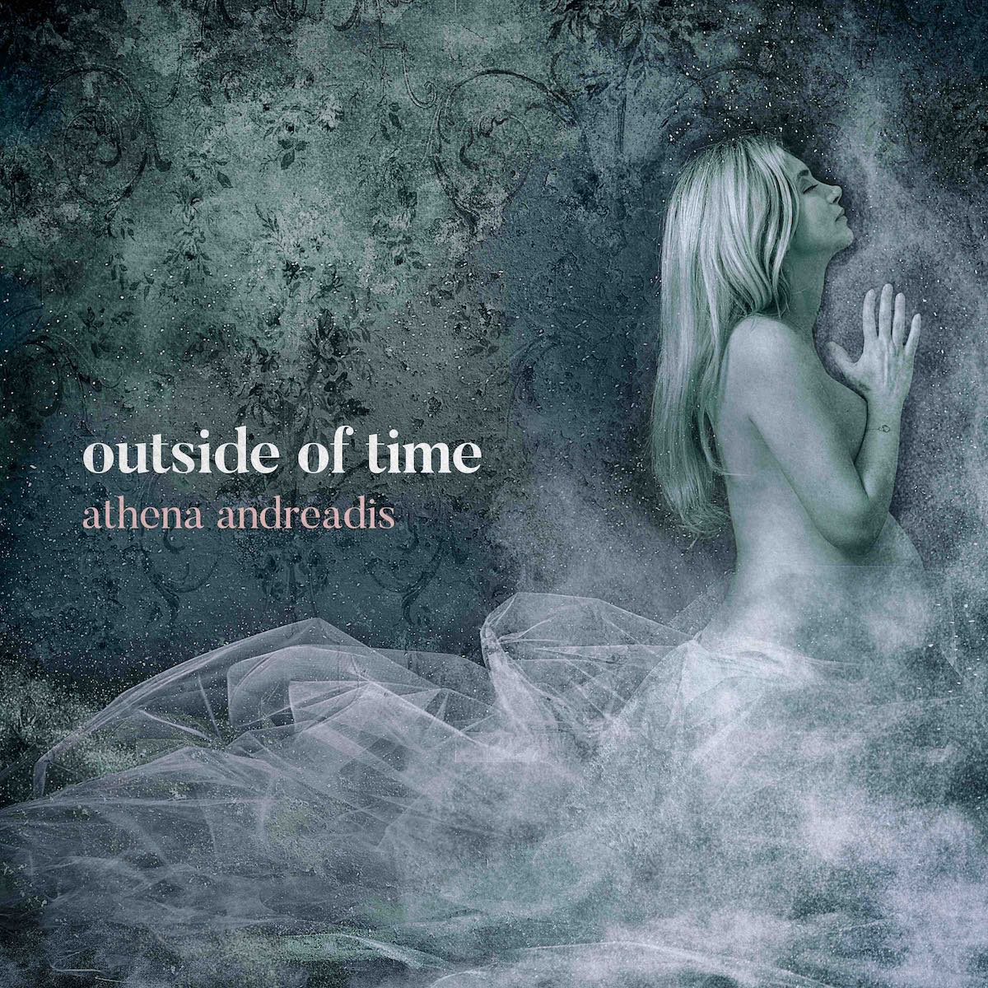

London born, Greek songstress Athena Andreadis shared her new album, Outside of Time, on June 12th 2020 and is releasing a new single, with a new video from the record, every two months. This is her second US record and fifth studio album. Her latest single, Brand New, has made it on more than 25 Spotify playlists. Her next single, Gave It All, will be released on February 11th, 2021.

A household name in Greece, a UK charting artist, a Leonard Cohen collaborator, Grammy Academy Voting Member and highly acclaimed throughout Europe and the USA, Athena has now teamed up with Grammy-nominated and acclaimed Producer Ethan Allen (who has worked among other with producers Brian Eno and Daniel Lanois, and artists like Counting Crows, Ben Harper, Mavis Staples, Sheryl Crow and Patty Griffin) recorded in Los Angeles, and mastered by Grammy-winner David Collins.

Some other musicians who performed on the record include legendary drummer and songwriter Brian MacLeod (Stevie Nicks, Tina Turner, Roger Waters), keys and Hammond Organ genius Tommy King (Madonna, Leona Lewis), and Jesse Ingles (Ben Harper, Ringo Starr) on double bass.

Athena also joined forces with legendary Billy Steinberg (one of the most successful songwriters of the past 25 years, writing five #1 singles on Billboard’s “Hot 100” chart, several top 10 U.S hits, including “Like A Virgin” by Madonna, “True Colors” by Cyndi Lauper, “How Do I Make You?” by Linda Ronstadt and “So Emotional” by Whitney Houston) and interpreted his powerful lyrics on the record’s single “Out of the Dirt”, a sentiment especially poignant now during the pandemic.

The record cover was created by photographer Monika Lightstone, who captured Athena pregnant and the pulse of the record.

Athena celebrated the record release with a live show from home in Los Angeles during lockdown via her FaceBook and Instagram pages (athenamusic). Her series “Fridays with Athena: Live from Home”, was a great success, broadcasting every Friday during LA lockdown to thousands of fans worldwide.

She also celebrated her birthday on June 14th with the release of a behind the scenes short documentary “Making of the Record: Outside of Time”, filmed and edited by Freddie Paull who captures the essence of the record and gives audiences a taste of Athena & Ethan’s journey behind the scenes.

“Brand New” is the latest single and music that Athena released. It inspired animator Avi Weinstein to create a unique video for it. The single has made it on more than 25 Spotify playlists and it has been exposed to a total of more than 28.870 listeners.

Most of the record was made while Athena was pregnant. It’s perhaps her most intimate, soulful and private record to date, with a meditative quality, and for that reason she chose to spend most of her time in the studio sculpting the record with her producer Ethan. They played most of the instruments themselves. To create the magical soundscape they envisioned, required not only concentration and stepping ‘outside of time’, but also the kind of flow and trust in one another that comes from a long term musical collaboration.

A firm believer in spirituality and life guiding you in the right direction, Athena moved to California five years ago after visiting LA and Joshua Tree in the California desert when she had a “calling” to move to the US. The move led her to collaborate with Leonard Cohen on his last album, You Want It Darker, where she is featured on the hauntingly beautiful, “Traveling Light” produced by Leonard’s son, Adam.

With international acclaim, and sold out UK, US and Greek tours, Athena has performed internationally at world class concert halls and festivals, including the Royal Festival Hall, Glastonbury, TEDx and SXSW. Her music has been in the top10 in both UK & Greek charts, and she is an award winning songwriter (Best Singer Songwriter Album at the IMAs). She was featured in a 1 hour British TV documentary about her music and career, called MyMusic: Athena in which her early mentor Chris Difford (Squeeze) talks about her heartfelt voice and lyrics. Athena's songs have been placed both in UK & US TV and films including Mike & Molly (CBS), Smash (NBC), Nomads (Lucy Liu), the London Olympics Visit England Campaign, and Fuller House (Netflix) where the entire cast (John Stamos, Jodie Sweetin) end the season singing one of Athena’s songs which also gained much Spotify playlist success.

In addition to her music, Athena is immersed in her philanthropic efforts and her charity work includes being an ambassador of the Plastic Pollution Coalition (Los Angeles) for which Rolling Stone magazine wrote about her alongside Maroon 5, Bonnie Raitt and Jackson Browne. She has collaborated internationally with Starbucks to help children, and charities like Concern Worldwide (humanitarian aid), Save The Children (UK and Germany), and has performed at environmental conference Galas like Cradle to Cradle (New York).

Outside of Time Album – PUBLIC LINK
On all Platforms
orcd.co/nj0xekp

Mini-documentary “Making of the Record: Outside of Time”- Official Video:
https://youtu.be/fEn7GDaZJ0w

Out of the Dirt Single - Official Video:
youtu.be/iF3Nc-oYETA

Voice of the Desert Single - Official Video:
https://youtu.be/A6mSNMUhjy8

Here and Now Single - Official Cinemagraph:
https://youtu.be/wfP-cKJN9L8

How to Love Single - Official Video:
https://youtu.be/v-8reR_xYJY

Brand New Single - Official Video:
https://youtu.be/SNbCY92pVQc

athenamusic.com
facebook.com/athenamusic
instagram.com/athenamusic
For more information, or interview requests, please contact info@embraceablerecords.com

Media assets: athenaandreadis.com/press

